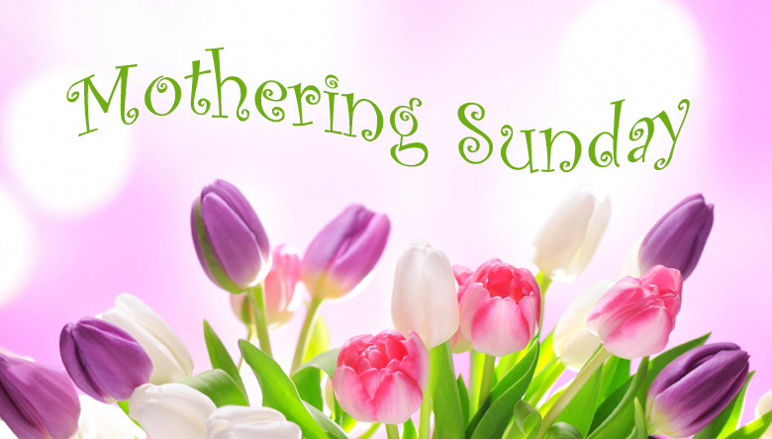

**Greeting**  
Praise God who loves us.   
**Praise God who cares.**

Today we celebrate love and thank God for his own perfect love for us all. We’re not all mothers ourselves but we all have a mother, whether or not they are still with us; and we’re all children of God. He is our loving Father but is also the one who remembers and comforts us as a mother comforts her child, and draws us close as a hen protects her chicks.

**Hymn number 468 Thank You Lord**

**Praising and thanking God**  
We light this candle to remind us that the love of God is like a light in our darkness. **Blessed be God for ever.**We light this candle, for all mothers who have loved and laughed and laboured as they cared for their children. **Blessed be God for ever.**We light this candle for all mothers who have wept in sorrow and joy for their children. **Blessed be God for ever**We light this candle for Jesus, born of a woman and nurtured in her love, and for Mary, a reminder of your patient, waiting love. **Blessed be God for ever.**

**Reading: Exodus 2.1-10**

**Confession**  
Let us call to mind our sin, our failure to value the love of others and our failure to love as Christ has loved us.  
*Keep a little silence for reflection*Your love gives us life from the moment of conception.  
We fail to live as your children.  
Lord have mercy.  
**Lord have mercy.**You call us to do good. We seek our own good.   
Christ, have mercy   
**Christ have mercy.**You hear us when we cry for help. We ignore the cries of others.  
Lord, have mercy.  
**Lord have mercy.**

**Hymn number 328 Make me a channel of your peace**

**Reflection**

**Prayers of Intercession**

**Prayer for all those who Mother us**

Praise God who loves us.  
**Praise God who cares.**For the care of those who mother us;   
**Thanks be to God.**For their patience when tested;   
**Thanks be to God.**For their love when tired;   
**Thanks be to God.**For their hope when despairing;   
**Thanks be to God.**For their service without limit;   
**Thanks be to God.**

**Thank you God for mothering love:  
Thank you God for care and concern;   
thank you God for the joys we share;   
thank you God for the pains we bear;   
thank you God for all we are given by you;   
through Jesus Christ our Lord.**

**Amen**

**Hymn 60 Bind Us Together**

**The Blessing**  
Praise God who loves us.  
**Praise God who cares.**May God, who gave birth to all creation, bless us:  
may God, who became incarnate by an earthly mother, bless us:  
may God, who broods as a mother over her children, bless us.  
May almighty God bless us, Father, Son and Holy Spirit,  
now and for ever

**Amen**